Rheumatic Fever – Course guide

In the following steps, you will register and enrol yourself in the Rheumatic Fever course.
Step | Action
Type the following URL into the browser address bar: learnonline.health.nz

Note you can use any of the following browsers to view this course:

Internet Explorer 8, 9 and 10, Firefox, Safari v5+, Google Chrome
Select the ‘Login’ link:

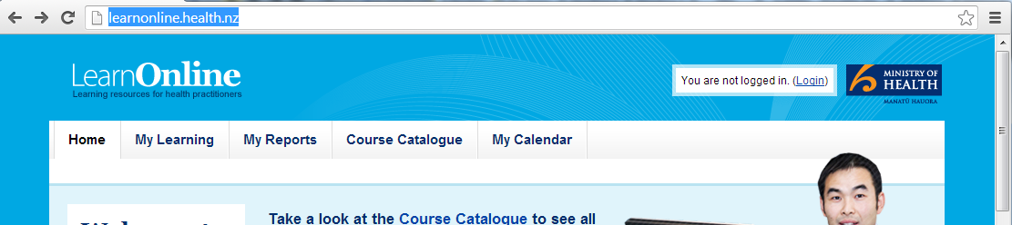
Select the ‘New Account’ link:

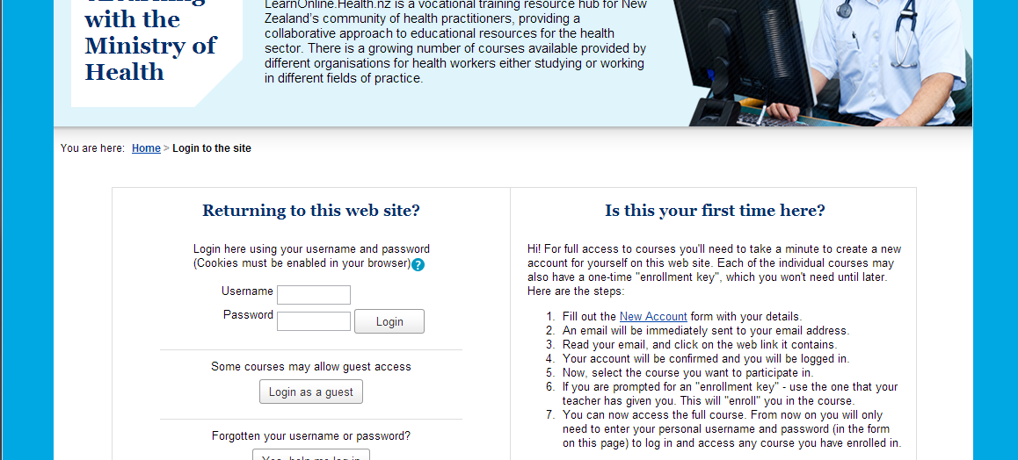

Fill out the form and then select ‘Create my new account’:

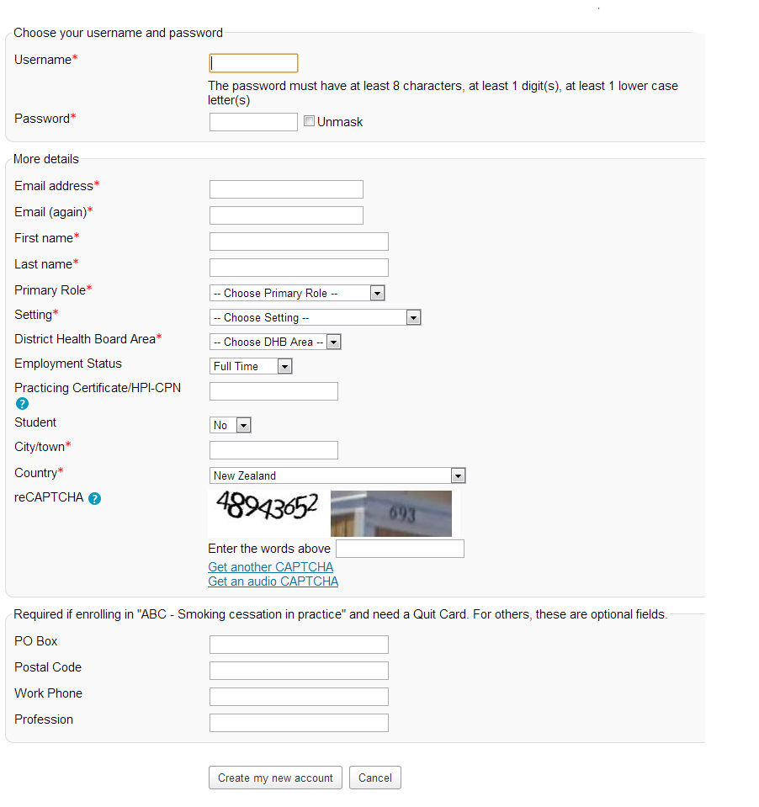

 | You will receive an email confirming your registration and requesting that you now activate your account. Follow the instructions in the email to do that. If you haven’t received an email within 2 minutes, check your email ‘spam’ folder.
Next, navigate to the Rheumatic Fever course as follows: Home > Course Catalogue > Rheumatic Fever

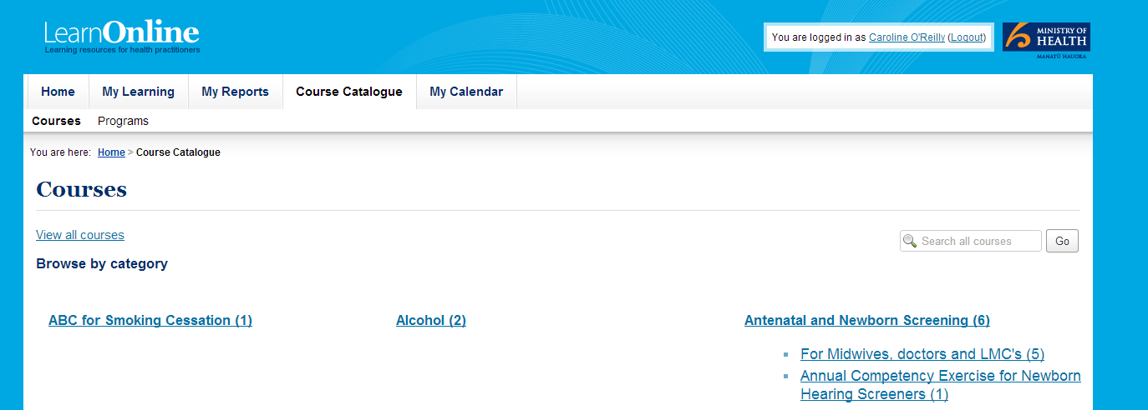
1.
2.

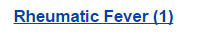
3. | Then select ‘Rheumatic Fever’:
Tip: Next time you want to access this course, you can use the course page address to navigate to it quickly. The easiest way to do that is to ‘bookmark’ the course page, or alternatively, you can add it to your ‘favourites’.

Your browser ‘Help’ provides instructions for ‘bookmarking’ and ‘favourites’.

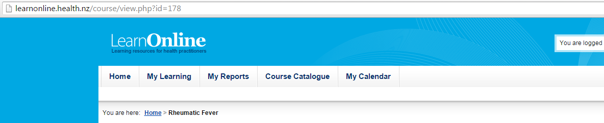

Work your way through the tasks on the Course Page, starting with ‘About this Resource’.

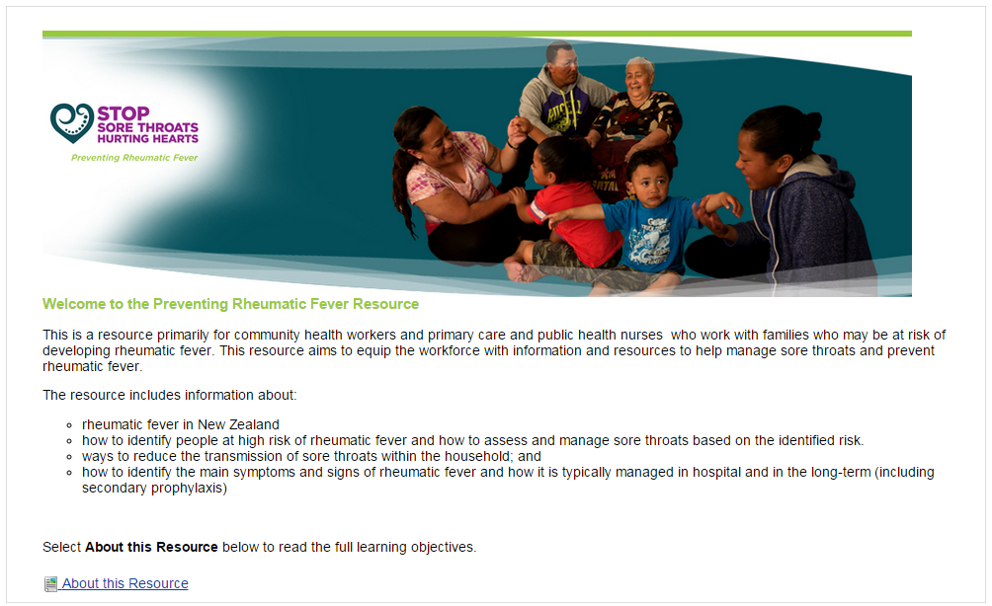

Work your way through all of the modules. (You must enable popups on your browser to view the modules.)

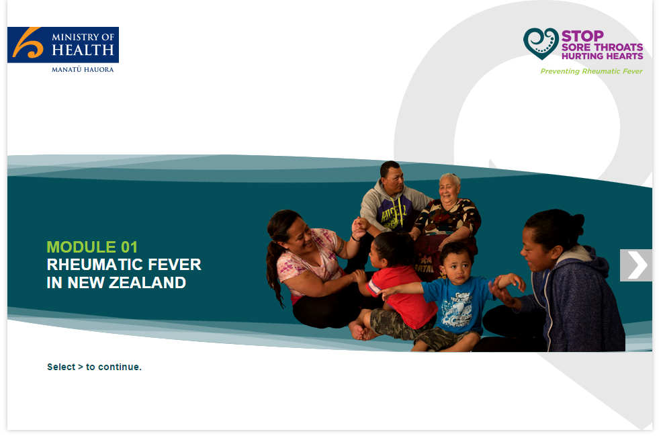

You must enable popups on your browser. If you need any help, you can view the link on “Support” block on the homepage.

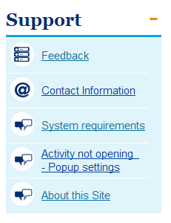
 | If you need any further any help please contact - learnonline@kineo.zohosupport.com

